Devops Project

Configure tomcat server on EC2 instance

Step1
Create an ec2 instance with 8090 port allow.
Login on ec2 instance.
Sudo su –
Yum install java-1.8* wget vim -y

Step2
Install Apache Tomcat
Download tomcat packages from https://tomcat.apache.org/download-80.cgi onto /opt on EC2 instance

cd /opt
wget http://mirrors.fibergrid.in/apache/tomcat/tomcat-8/v8.5.35/bin/apache-tomcat-8.5.35.tar.gz
tar -xvzf /opt/apache-tomcat-8.5.35.tar.gz
chmod +x /opt/apache-tomcat-8.5.35/bin/startup.sh shutdown.sh
ln -s /opt/apache-tomcat-8.5.35/bin/startup.sh /usr/local/bin/tomcatup
ln -s /opt/apache-tomcat-8.5.35/bin/shutdown.sh /usr/local/bin/tomcatdown
tomcatup

check point :
Access tomcat application from browser on port 8080
http://<Public_IP>:8080
Using unique ports for each application is a best practice in an environment. But tomcat and Jenkins runs on ports number 8080. Hence lets change tomcat port number to 8090. Change port number in conf/server.xml file under tomcat home

cd /opt/apache-tomcat-8.5.35/conf
# update port number in the "connecter port" field in server.xml
# restart tomcat after configuration update
tomcatdown
tomcatup

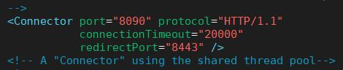
Step3
check point :
Access tomcat application from browser on port 8090
http://<Public_IP>:8090
now application is accessible on port 8090. but tomcat application doesnt allow to login from browser. changing a default parameter in context.xml does address this issue

#search for context.xml
find / -name context.xml

Above command gives 3 context.xml files. comment () Value ClassName field on files which are under webapp directory. There will be 2 files under webapp directory. After that restart tomcat services to effect these changes
After comment file “ /opt/apache-tomcat-8.5.31/webapps/host-manager/META-INF/context.yml ” will look like:

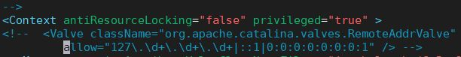

After comment file “ /opt/apache-tomcat-8.5.31/webapps/manager/META-INF/context.yml ” will look like:

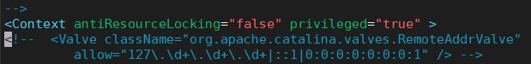

tomcatdown
tomcatup

Step4
Update users information in the tomcat-users.xml file go to tomcat home directory and Add below users to conf/tomcat-user.xml file
vim apache-tomcat-8.5.51/conf/tomcat-users.xml

<role rolename="manager-gui"/>
<role rolename="manager-script"/>
<role rolename="manager-jmx"/>
<role rolename="manager-status"/>
<user username="admin" password="admin" roles="manager-gui, manager-script, manager-jmx, manager-status"/>
<user username="deployer" password="deployer" roles="manager-script"/>
<user username="tomcat" password="s3cret" roles="manager-gui"/>

File will be like:
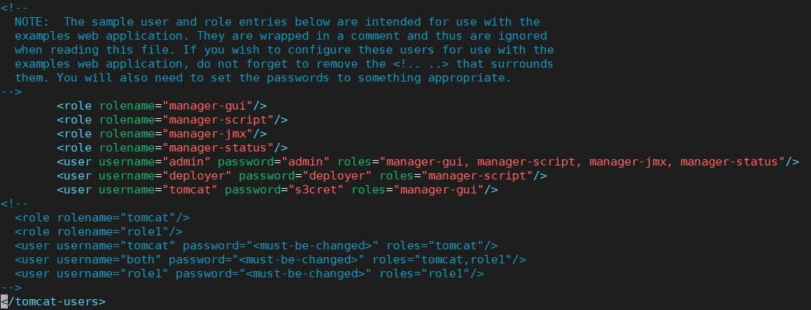

Restart serivce and try to login to tomcat application from the browser. This time it should be Successful.
Now login with :-
User : tomcat
Password : s3cret

Configure Jenkins and maven server on EC2 instance

Install Jenkins on AWS EC2
Jenkins is a self-contained Java-based program, ready to run out-of-the-box, with packages for Windows, Mac OS X and other Unix-like operating systems. As an extensible automation server, Jenkins can be used as a simple CI server or turned into the continuous delivery hub for any project.

Prerequisites
- EC2 CENTOS 7.x Instance Get help here
  - With Internet Access
  - Security Group with Port 8080 open for internet
- Java v1.8.x

Install Java
We will be using open java for our demo, Get latest version from http://openjdk.java.net/install/
yum install java-1.8*
#yum -y install java-1.8.0-openjdk

Confirm Java Version
Lets install java and set the java home
java -version
find /usr/lib/jvm/java-1.8* | head -n 3
#JAVA_HOME=/usr/lib/jvm/java-1.8.0-openjdk-1.8.0.191.b12-1.el7_6.x86_64
export JAVA_HOME
PATH=$PATH:$JAVA_HOME
# To set it permanently update your .bash_profile
source ~/.bash_profile

.bash_profile file will be like: (Maven path do not set right now. Set it when you install maven)
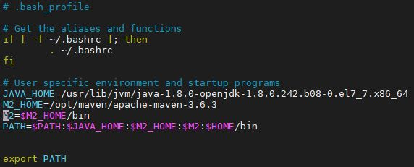
Run this command after changing into file : source ~/.bash_profile

Install Jenkins
You can install jenkins using the rpm or by setting up the repo. We will setup the repo so that we can update it easily in future. Get latest version of jenkins from https://pkg.jenkins.io/redhat-stable/
yum -y install wget
wget -O /etc/yum.repos.d/jenkins.repo https://pkg.jenkins.io/redhat-stable/jenkins.repo
rpm --import https://pkg.jenkins.io/redhat-stable/jenkins.io.key
yum -y install jenkins

Start Jenkins
# Start jenkins service
systemctl start jenkins

# Setup Jenkins to start at boot,
systemctl enable jenkins

Accessing Jenkins
By default jenkins runs at port 8080, You can access jenkins at
http://YOUR-SERVER-PUBLIC-IP:8080

Configure Jenkins
- The default Username is admin
- Grab the default password
  - Password Location:/var/lib/jenkins/secrets/initialAdminPassword
- Skip Plugin Installation; We can do it later
- Change admin password
  - Admin > Configure > Password
- Configure java path
  - Manage Jenkins > Global Tool Configuration > JDK (it will look like this below)
  - Find the path of JAVA_HOME By “ find / -name javac “
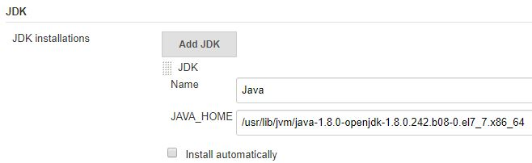
- Create another admin user id

Test Jenkins Jobs
- Create “new item”
- Enter an item name – My-First-Project
  - Chose Freestyle project
- Under Build section Execute shell : echo "Welcome to Jenkins Demo"
- Save your job
- Build job
- Check "console output"

Install Maven on AWS EC2
Login into ec2 instance.
go to maven.apache.org/download.cgi to download apache-maven.tar.gz
mkdir /opt/maven
cd /opt/maven
Wget <link>
Tar –xvzf apache-maven-3.6.3
Cd apache-maven-3.6.3
Edit /root/.bash_profile
File will look like:

- Install maven plugin to Jenkins
  - Manage Jenkins > Manage Plugins > Available > search unleash maven > install it (it will look like this below)
- Configure Maven path
  - Manage Jenkins > Global Tool Configuration > Maven (it will look like this below)
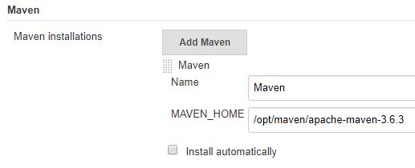
Install git on Jenkins server
Yum install git –y
- Install git plugin to Jenkins
  - Manage Jenkins > Manage Plugins > Available > search github > install it (it will look like this below)
- Configure Git path
  - Manage Jenkins > Global Tool Configuration > Git (it will look like this below)
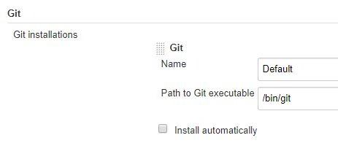
Create a new project

Part-01 : Adding steps for Integration

Steps to create Jenkin job
- Login to Jenkins console
- Create Jenkins job, Fill the following details,
  - Source Code Management:
    - Repository: https://github.com/ValaxyTech/hello-world.git
    - Branches to build : */master
  - Build:
    - Root POM:pom.xml
    - Goals and options : clean install package

Part-02: Adding Deployment Steps
in this port we are going to install 'deploy to container' plugin. this is need to deploy on tomcat server which we are using.
- Install maven plugin without restart
  - Manage Jenkins > Jenkins Plugins > available > deploy to container
To deploy our build artifacts on tomcat server our Jenkins server need access. For this we should setup credentials. This option is available in Jenkins home page
- setup credentials
  - credentials > jenkins > Global credentials > add credentials
    - Username : deployer
    - Password : XXXXXXX
    - id : Tomcat_user
    - Description: Tomcat user to deploy on tomcat server
Modify the same job which created in part-01 and add deployment steps.
- Post Steps
  - Deploy war/ear to container
    - WAR/EAR files : **/*.war
    - Containers : Tomcat 8.x
      - Credentials: Tomcat_user (which created in above step)
      - Tomcat URL : http://<PUBLIC_IP>:<PORT_NO>
Save and run the job now.

